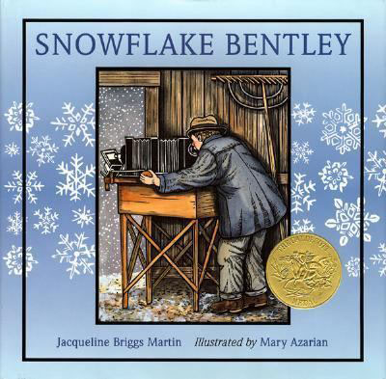
Snowflake Bentley by Jacqueline Briggs Martin and illustrated by Mary Azarian, a fictional biography packed with informational tidbits, highlights the life of a determined individual who followed his dream and impacted the world despite what others believed was or was not important.
From the time he was a small boy in Vermont, Wilson Bentley saw snowflakes as small miracles. And he determined that one day he would capture for others the wonder of the tiny crystals. Bentley's enthusiasm for photographing snowflakes was often misunderstood in his time, but his patience and determination revealed two important truths: no two snowflakes are alike; and each one is startlingly beautiful. His story is gracefully told and brought to life in lovely woodcuts, giving the reader insight into a soul who had not only a scientist's vision and perseverance but a passion for the wonders of nature. It is one of those stories every child should know.

Purpose:
January is a time of year when we all think about what we need to do to better ourselves, but setting goals and persevering to accomplish them isn’t a skill that comes naturally to most of us, but these skills can be developed.
Start by setting goals to go for dreams: Talk with children about dreams and goals. Discuss Wilson Bentley’s dream to share the beauty of snowflakes with the world. To reach his dream, he needed to develop goals along the way such as figuring out how to photograph snowflakes and adjust those goals along the way.
Activity: Develop perseverance while cutting snowflakes with 6 points the same way they appear in nature;
- Explain that many of us may have cut snowflakes in the past, but those likely had 4 or 8 points. Ask children how many points snowflakes made in nature have? (Answer: 6)Tell them that some tasks are hard and require us to try and try again just like Snowflake Bentley needed to persevere to accomplish his dream.
Demonstrate how to fold paper to cut a snowflake asking students to mimick each fold on their own paper. Find directions here: http://images.magnetmail.net/images/clients/NCTM1/attach/snowflake.pdf

Activity; Build toward a goal
- Write a goal on an index card.
- Discuss what can be done to help accomplish the goal
- On a second index card draw a picture to represent the goal
- Cut a second index card into 3 to 5 puzzle pieces.
- Write one step toward the goal on each puzzle piece.
- Use small pieces of rolled masking tape to tape the puzzle pieces over the goal.
- As each step is accomplished remove it from the goal card to slowly over time reveal the goal.
- Celebrate the accomplishment of the goal.

Other resources:
http://www.parents.com/parenting/better-parenting/style/how-to-teach-kids-perseverance-goal-setting/

